Tony’s Easter Product Descriptions

egg-stra special chocolate eggs
Easter eggs assortment, 150g, £4.49
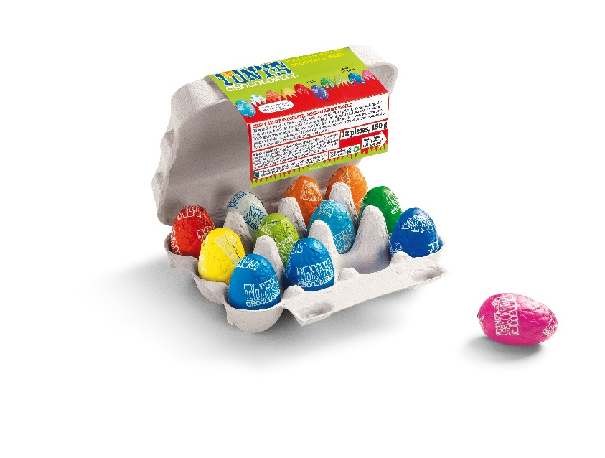

Description:

12 eggs divided by 10 flavours, that's ehh.. not equal! This carton is un-egg-ually divided, just like our bars - to illustrate the inequality in the chocolate industry. We exist to end slavery in the chocolate industry. Our mission is to make 100% slave free the norm in chocolate. Together with you. Are you in?
Which egg is which? Red: milk chocolate, Dark Blue: extra dark, Yellow: milk almond honey nougat, Orange: milk caramel sea salt, Light Blue: dark milk, Green: dark almond sea salt, Dark Green: milk hazelnut, Purple: milk pretzel toffee, Pink: white raspberry popping candy, White: white chocolate.
Dark, dark milk, milk, white chocolate with pieces of hazelnut, nougat, caramel, almond, freeze-dried raspberry, popping sugar and sea salt.

Ingredients:

DARK CHOCOLATE:cocoa mass, sugar, cocoa butter, emulsifier (soya lecithin),MILK CHOCOLATE CARAMEL SEA SALT:sugar, dried whole milk, cocoa butter, cocoa mass, 10.00% caramel pieces (sugar, glucose syrup, cream (milk), butter (milk)), 0.50% sea salt, emulsifier (soya lecithin),MILK CHOCOLATE:sugar, dried whole milk, cocoa butter, cocoa mass, emulsifier (soya lecithin),DARK MILK CHOCOLATE PRETZEL TOFFEE:sugar, cocoa mass, dried whole milk, cocoa butter, 7.22% pretzel pieces (wheat flour, salt, sunflower oil, malted wheat flour, yeast, acidity regulator (sodium hydroxide)), 2.78% caramel (sugar, glucose syrup), sea salt, emulsifier (soya lecithin),MILK CHOCOLATE HAZELNUT:sugar, dried whole milk, cocoa butter, cocoa mass, 10.00% hazelnuts, emulsifier (soya lecithin),MILK CHOCOLATE ALMOND HONEY NOUGAT:sugar, dried whole milk, cocoa butter, cocoa mass, 10.00% honey-almond-nougat (cane sugar, glucose syrup, almonds, potato starch, 0.10% honey, cocoa butter, egg white), emulsifier (soya lecithin),DARK MILK CHOCOLATE:sugar, cocoa mass, dried whole milk, cocoa butter, emulsifier (soya lecithin),WHITE CHOCOLATE:sugar, cocoa butter, dried whole milk, emulsifier (soya lecithin),DARK CHOCOLATE ALMOND SEA SALT:cocoa mass, sugar, 10.00% almonds, cocoa butter, 0.50% sea salt, emulsifier (soya lecithin),WHITE CHOCOLATE RASPBERRY POPPING CANDY:sugar, cocoa butter, dried whole milk, 2.70% freeze-dried raspberry, 2.00% popping candy (glucose syrup, sugar, natural gas (carbon dioxide)), emulsifier (soya lecithin)

May contain traces of peanuts.

Product information:

EAN code: 8719956496769

Nutritional values:

per 100 grams:
Energy - 2,276 kJ / 544 kcal
Total Fat - 34 g
of which saturated - 19.8 g
Total Carb. - 50.5 g
of which sugar - 48.0 g
Protein - 7.0 g
Salt - 0.29 g

Fairtrade statement:

Fairtrade cocoa, sugar and honey. Sugar with mass balance. Minimal 69%. info.fairtrade.net/sourcing

Storage advice:

Store in a cool, dry and dark place, but not in the fridge.

Other information:

Suitable for vegetarians, not suitable for vegans.

..
milk lemon meringue 32%
180g, 1 bar, £3.98

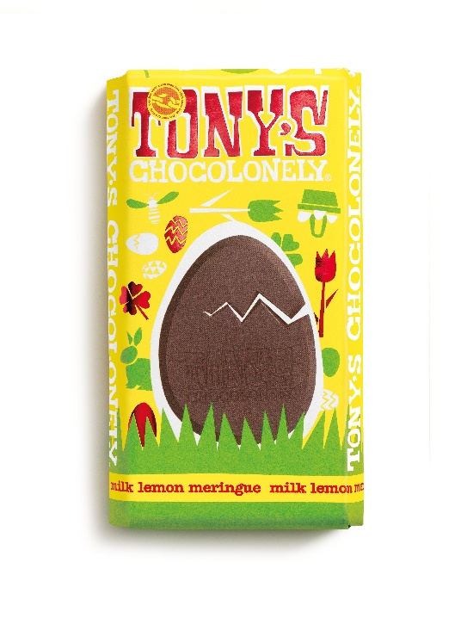

Description:

Is it an Easter egg? Is it a regular chocolate bar? No! It's the Tony's Chocolonely Easter bar! This Easter bar will make your Easter days a chocolate heaven: Fairtrade milk chocolate with meringue (made from free-range eggs) and a hint of lemon. Break the egg out of the bar for more chocolate fun this Easter.
Belgian Fairtrade milk chocolate with freeze-dried lemon and meringue. Cocoa solids: 32% minimum. Milk solids: 21% minimum. Made in Belgium.

Ingredients:

sugar, dried whole milk, cocoa butter, cocoa mass, 3.33% meringue (sugar, egg white, wheat starch), 1.94% freeze-dried lemon (glucose syrup, apricot, lemon juice concentrate, sugar, modified starch, thickening agent (sodium alginate)), emulsifier (soya lecithin)

May contain traces of peanuts and tree nuts.

Product information:

EAN code: 8719956491269

Nutritional values:

per 100 grams:
Energy - 2,250 kJ / 537 kcal
Total Fat - 31 g
of which saturated - 18.9 g
Total Carb. - 54.0 g
of which sugar - 52.6 g
Protein - 7.4 g
Salt - 0.20 g

May contain traces of peanuts, gluten and nuts.
Fairtrade statement:

Fairtrade cocoa and sugar. Sugar with mass balance. Total 73%. Visit info.fairtrade.net/sourcing

Storage advice:

Store in a cool, dry and dark place, but not in the fridge.

Other information:

Suitable for vegetarians, not suitable for vegans.

..
Easter egg milk caramel sea salt pouch
Easter eggs milk caramel sea salt pouch, 178g, 14 eggs, £4.99

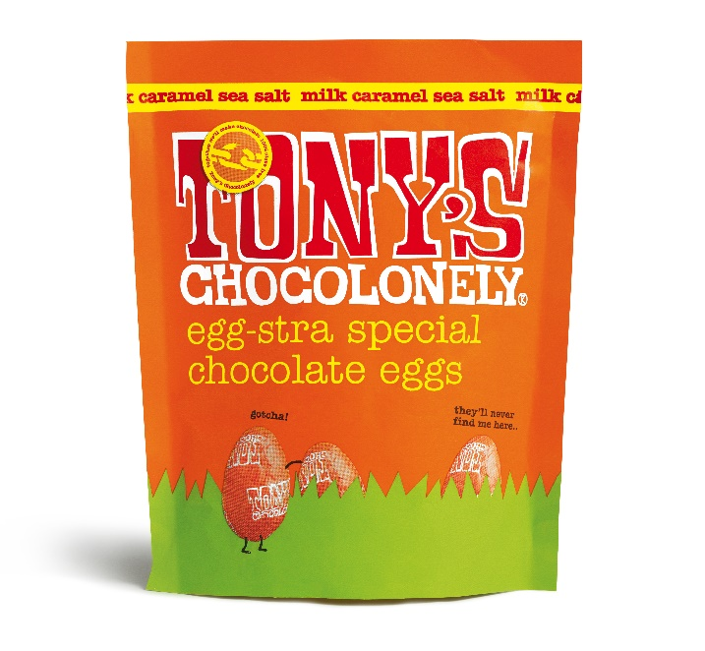

Description:

Our little Easter eggs are back in your favourite flavours! Enjoy 14 milk caramel sea salt 32% eggs.. but this time in a paper pouch so they’re easier to share/not share. We’re not judging!
- Fairtrade
- No palm oil
- No plastic

Ingredients:

sugar, dried whole milk, cocoa butter, cocoa mass, 10.00% caramel pieces (sugar, glucose syrup, cream (milk), butter (milk)), 0.50% sea salt, emulsifier (soya lecithin)
May contain traces of gluten, eggs, peanuts and tree nuts.

Product information:

EAN code: 8719956496301

Nutritional values:

per 100 grams:
Energy - 2,247 kJ / 537 kcal
Total Fat - 32 g
of which saturated - 19.3 g
Total Carb. - 54.3 g
of which sugar - 51.1 g
Protein - 6.9 g
Salt - 0.69 g

Fairtrade statement:

Fairtrade cocoa and sugar. Sugar with mass balance. Total 69%. Visit info.fairtrade.net/sourcing
Storage advice
Store in a cool, dry and dark place, but not in the fridge.

Other information:

Suitable for vegetarians, not suitable for vegans.

..
Easter eggs milk pouch
Easter eggs milk pouch, 180g, £4.99

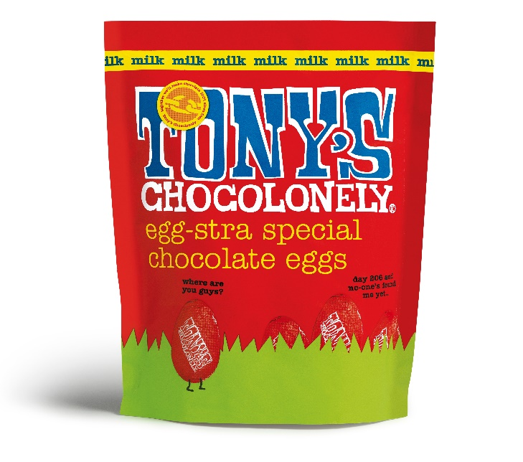

Description:

Our little Easter eggs are back in your favourite flavours! Enjoy 14 milk 32% eggs.. but this time in a paper pouch so they’re easier to share/not share. We’re not judging!
- Fairtrade
- No palm oil
- No plastic

Ingredients:

sugar, dried whole milk, cocoa butter, cocoa mass, emulsifier (soya lecithin)
May contain traces of gluten, eggs, peanuts and tree nuts.

Product information:
EAN code: 8719956496288

Nutritional values:

per 100 grams:
Energy - 2,280 kJ / 545 kcal
Total Fat - 33 g
of which saturated - 20.0 g
Total Carb. - 51.9 g
of which sugar - 50.7 g
Protein - 7.7 g
Salt - 0.21 g

Fairtrade statement:

Fairtrade cocoa and sugar. Sugar with mass balance. Total 77%. Visit info.fairtrade.net/sourcing

Storage advice:

Store in a cool, dry and dark place, but not in the fridge.

Other information:

Suitable for vegetarians, not suitable for vegans.

..
Easter eggs mixed pouch
Easter eggs mixed pouch, 255g, 20 eggs, £5.99
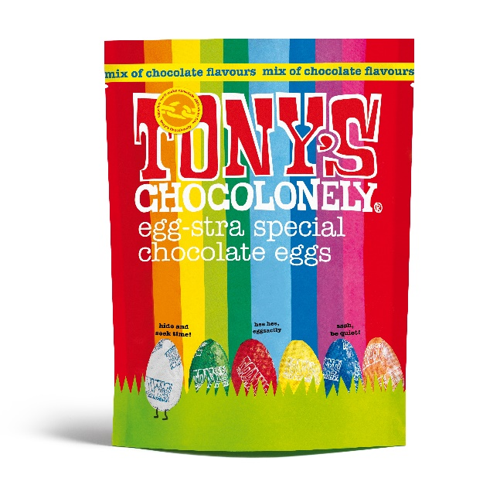

Description:

Our little Easter eggs are back in your favourite flavours! Enjoy 20 eggs in a range of our bestselling flavours.. but this time in a paper pouch so they’re easier to share/not share. We’re not judging!
Flavours included:
Flavours in each pouch:
Milk 32%
Milk caramel sea salt 32%
Milk hazelnut 32%
Milk almond honey nougat 32%
Dark milk 42%
Dark almond sea salt 51%
Extra Dark 70%
White 28%
- Fairtrade
- No palm oil
- No plastic

Ingredients:

DARK CHOCOLATE:cocoa mass, sugar, cocoa butter, emulsifier (soya lecithin),MILK CHOCOLATE:sugar, dried whole milk, cocoa butter, cocoa mass, emulsifier (soya lecithin),MILK CHOCOLATE CARAMEL SEA SALT:sugar, dried whole milk, cocoa butter, cocoa mass, 10.00% caramel pieces (sugar, glucose syrup, cream (milk), butter (milk)), 0.50% sea salt, emulsifier (soya lecithin),WHITE CHOCOLATE:sugar, cocoa butter, dried whole milk, emulsifier (soya lecithin),MILK CHOCOLATE HAZELNUT:sugar, dried whole milk, cocoa butter, cocoa mass, 10.00% hazelnuts, emulsifier (soya lecithin),MILK CHOCOLATE ALMOND HONEY NOUGAT:sugar, dried whole milk, cocoa butter, cocoa mass, 10.00% honey-almond-nougat (cane sugar, glucose syrup, 2.00% almonds, potato starch, 0.10% honey, cocoa butter, egg white), emulsifier (soya lecithin),DARK MILK CHOCOLATE:sugar, cocoa mass, dried whole milk, cocoa butter, emulsifier (soya lecithin),DARK CHOCOLATE ALMOND SEA SALT:cocoa mass, sugar, 10.00% almonds, cocoa butter, 0.50% sea salt, emulsifier (soya lecithin)
May contain traces of gluten, eggs, peanuts, milk and tree nuts.

Product information:

EAN code: 8719956496264

Nutritional values:

per 100 grams:
Energy - 2,283 kJ / 546 kcal
Total Fat - 34 g
of which saturated - 19.9 g
Total Carb. - 50.6 g
of which sugar - 48.5 g
Protein - 7.0 g
Salt - 0.27 g

Fairtrade statement:

Fairtrade cocoa, sugar and honey. Sugar with mass balance. Minimal 69%. info.fairtrade.net/sourcing

Storage advice:

Store in a cool, dry and dark place, but not in the fridge.

Other information:

Suitable for vegetarians, not suitable for vegans.

